**TECHNOLOGY STACK**

|  |  |
| --- | --- |
| **TEAM ID** | NM2025TMID02997 |
| **PROJECT NAME** | Educational Organisation Using ServiceNow |

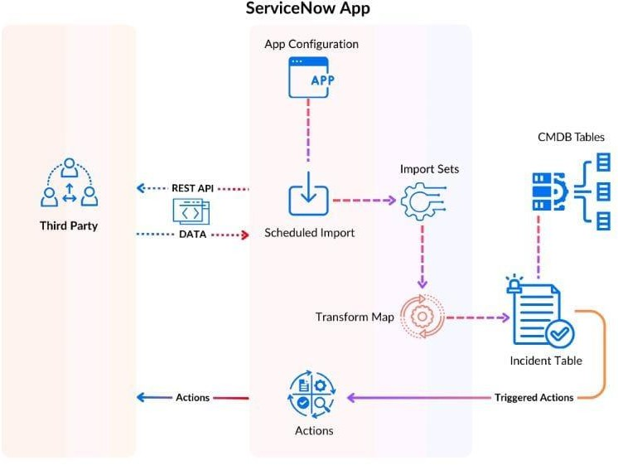

demonstrating how it interacts with a third-party system and manages IT Service Management (ITSM) data.

Third-Party Integration:

A third-party system can interact with the ServiceNow app via a REST API to send or receive data.

CMDB Tables:

The CMDB (Configuration Management Database) Tables are central to ServiceNow, storing configuration items and their relationships, which are crucial for ITSM processes.

Actions and Triggered Actions:

The system allows for actions to be performed, either initiated by the third party or triggered by events within ServiceNow, such as updates to the Incident Table.

Data Import and Transformation:

Data from the third party or other sources can be brought into ServiceNow through Scheduled Imports, which utilize Import Sets for staging and Transform Maps to map the data to the correct fields in tables like the Incident Table.